|  |  |
| --- | --- |
| NAME | Muhammad Arslan Raza |
| ROLL# | 2020-EE-403 |

**ASSIGNMENT**

**(**Simple Linear Regressions**)**

**Definition:**

**Simple linear regression** is a statistical method that allows us to summarize and study relationships between two continuous (quantitative) variables:

1-One variable, denoted *x*, is regarded as the **predictor**, **explanatory**, or **independent** variable.

2-The other variable, denoted *y*, is regarded as the **response**, **outcome**, or **dependent** variable.

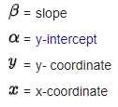formula.PNG**Formula:**

**Task:**  
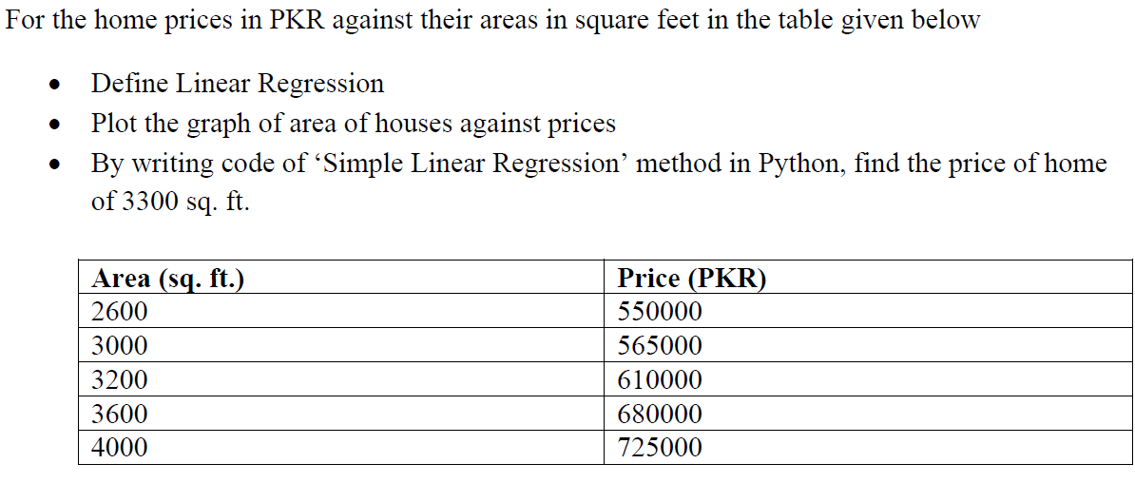

**Solution:**

First, I install the NumPy, matplotlib, matplot and sklearn using the package installer in Thonny (PyPl). Now, I write code.

**Code:**

import numpy as np

import matplotlib.pyplot as plt

from sklearn.linear_model import LinearRegression

area=np.array([2600,3000,3200,3600,4000]).reshape(-1,1)

price=np.array([550000,565000,610000,680000,725000])

reg_model=LinearRegression()

reg_model.fit(area,price)

r_squared=reg_model.score(area,price)

slope=reg_model.coef_[0]

intercept=reg_model.intercept_

pred_price=reg_model.predict(area)

price_req=np.array([3300]).reshape(-1,1)

pred_price_req=reg_model.predict(price_req)[0]

print("R-Squared",r_squared)

print("Slope of curve=",slope)

print("Intercept of curve=",intercept)

print("The predicted function is y=",str(slope)+"(x)+",intercept)

print("Price for Area=3300 sq.ft=",pred_price_req,"PKR")

plt.plot(area,price,linestyle='solid',marker='o')

plt.plot(area,pred_price,linestyle='dotted')

plt.ylabel("Price(PKR)")

plt.xlabel("Area(sq.ft)")

plt.show()

**Output:**

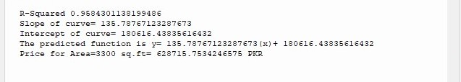

**Plot:**

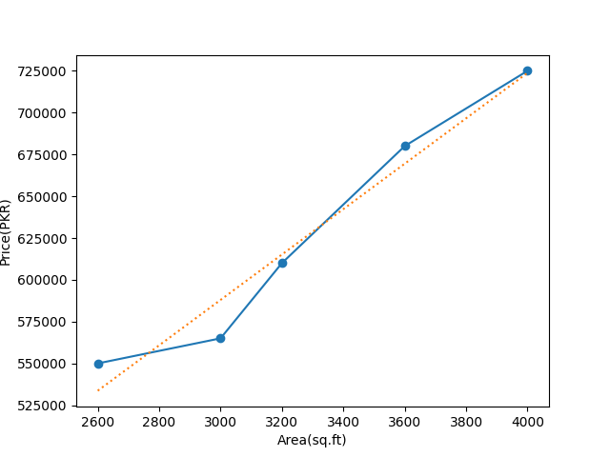

**Conclusion:**

In the above code, I have to predict home prices using linear regression. First, I have to import the required modules then make two arrays of sample data. After this, I will create my model and I will use. fit **method** to calibrate my values in my model. Then I will calculate the coefficient of determination which is known as **R-squared**. Now I use the methods. coefficient and. intercept. I can use. predict **()** to predict the value of given regression. In plot the solid blue line shows the actual plot for given data and the dotted red line shows the estimated linear aggression. The predicted value for a given regression will be **628715.7534246575 PKR**.